Smith, Bob (based on Conservation News 2006)
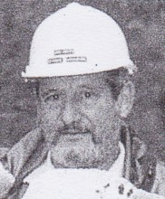
Started with the Forests Department at Nannup in 1969 and moved to Manjimup in 1971 as a technical officer, specialising in fire research, silviculture and forest monitoring. Involved in two major collaborative research projects with the CSIRO, Project Aquarius and Project Vesta. Involved in ForestCheck monitoring project. Retired 2006.

